**Props and Destructuring**

What is props ?

Actually when we want to create a card or something else and we don’t want the same cards as well and we want to specify the name or the title of the card inside the code then we use props. Actually we can use props or any word we want .

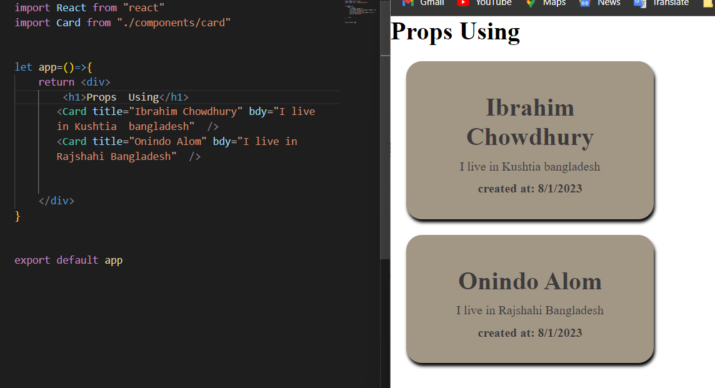

What we have write here will appear in the browser

How We can use Props in Our projects?

1st , we have created a card on card.js in the component section and go to the app.js and there declare the card as

<Card tiltle=”write anthing ” />

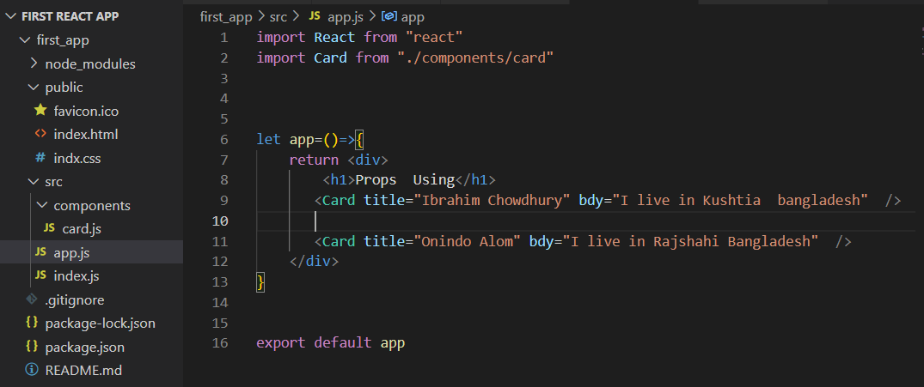

Here we have declare 2 card and give the title and bdy in the card section

2nd , go to the card.js

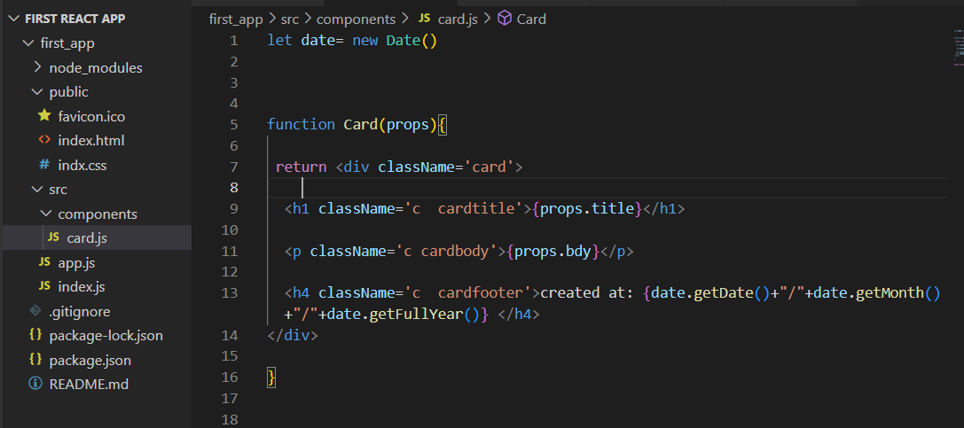

Declare the tile as props.title what we have put in the card section

Declare anything props or something else

**What is Destructuring?**

এর মানে হচ্ছে ভেঙ্গে ভেঙ্গে দেওয়া । that means একটি arrey কে ভেঙ্গে ভেঙ্গে আলাদা ভাবে করে নেওয়া

One thing we must have to remember that what we give name into our app section in the card that must be when we give name to the desturctured props name

**How we do desctructuring in our projects?**

1st , go to te card.js file and there

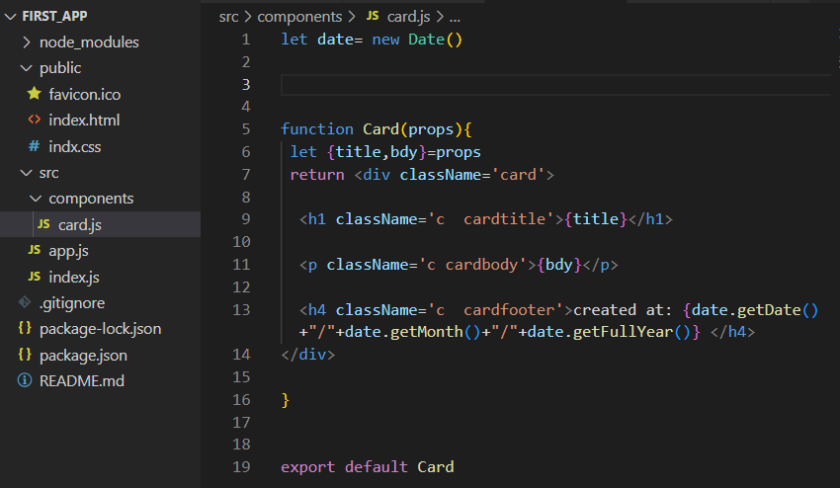

Here we have done distuctured the props into title and bdy